# Azure Fundamentals

Azure is a cloud computing platform

Sandbox is a temporary Azure portal environment.

Learning Objectives

Define cloud computing

Shared responsibility model

Cloud models (Private, public, hybrid)

The use case for each cloud

Consumption-based model

Cloud pricing models

IAAS:

Compute, Networking, Storage, Databases

Benefits of Could computing:

Cost-effectiveness: pay-as-go feature

Global: anywhere in the world

Secure: Secure by default

Reliable: backup, disaster recovery, data replication, fault tolerance

Scalable: Inc or Dec resources based on Demand

Elastic: Automate scaling

Current: software is patched and auto upgraded

**Type of Could Computing:**

SaaS: Software as service e.g. salesforce, Gmail, office 365

PaaS: Platform as Service

IaaS: Infrastructure as Service e.g. Azure, AWS, Oracle cloud

**Type of Cloud Computing Responsibilities:**

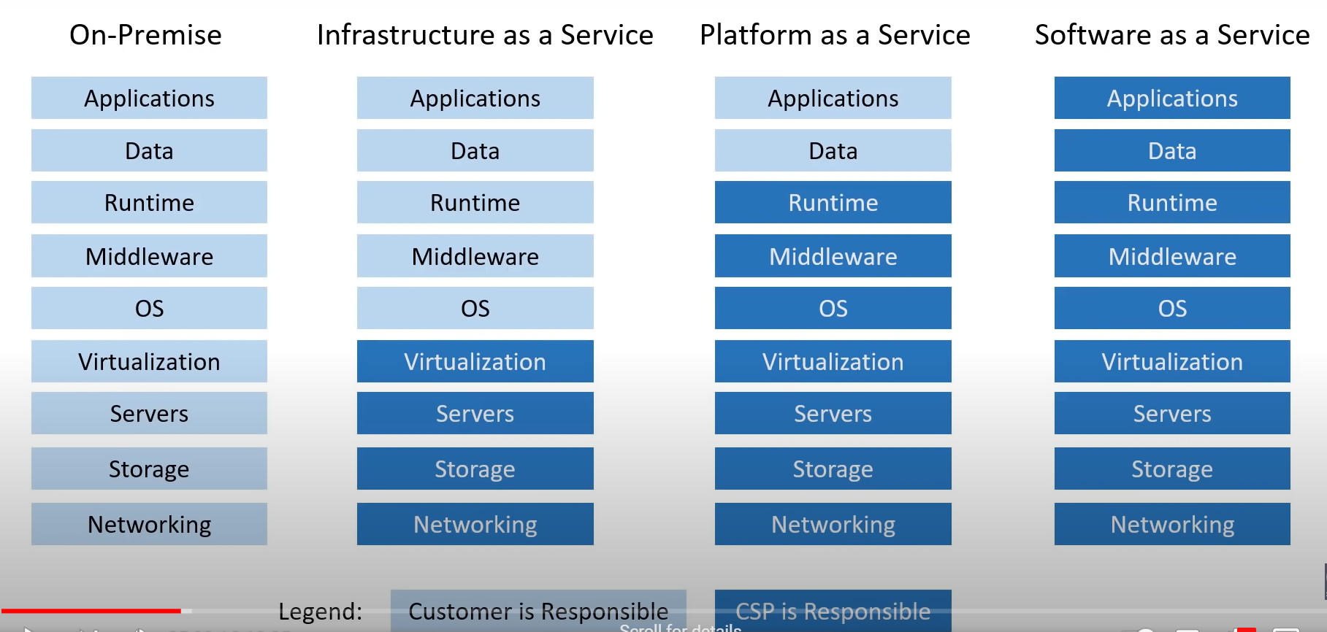

**Azure Deployment Models:**

Public Cloud: also known as Could Native {vm running and a DB running}

Private Cloud:

Hybrid Cloud:

Pro’s & Con’s:

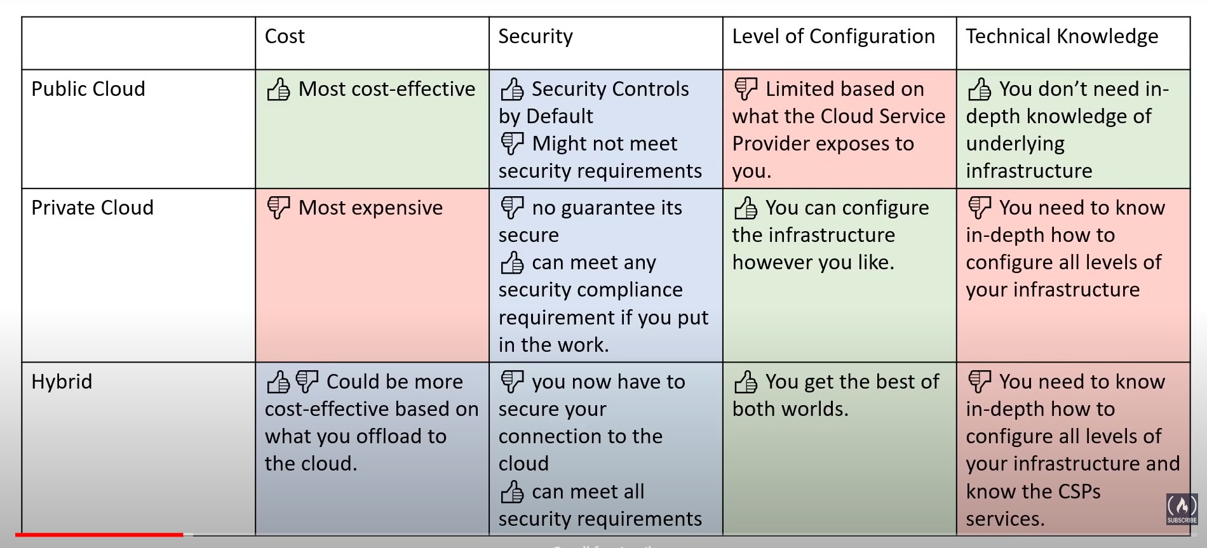

Cross-Cloud:

Using Multiple Cloud Providers

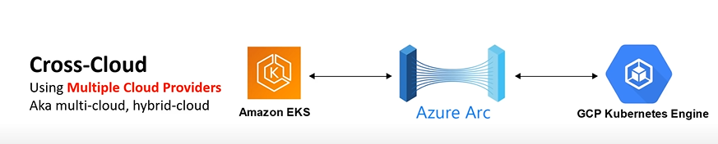

**Total Cost of Ownership (TCO):**

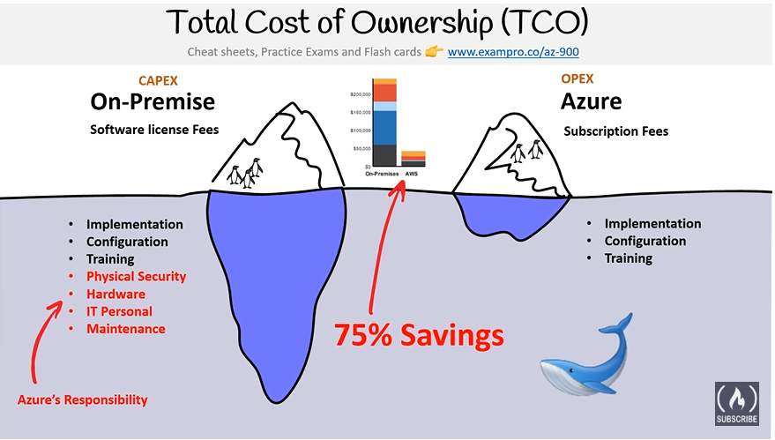

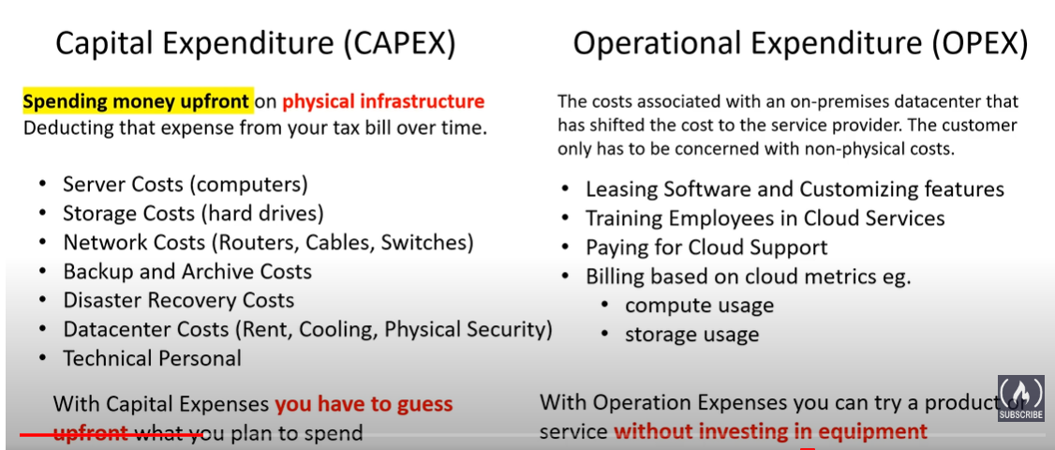

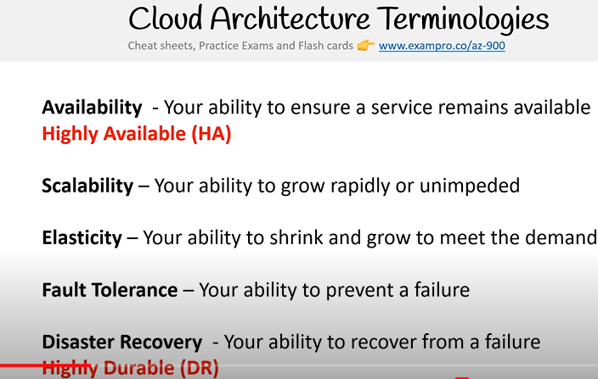

**Scalability:** your ability to increase your capacity based on increasing demand of traffic, memory and computing power

Vertical scaling 🡪 Upgrading to bigger servers

Horizontal Scaling 🡪 adding more servers of the same size

**Elasticity:** Automatically inc or dec of capacity based on the current demand of traffic, memory, and computing power

Horizontal scaling

Scaling out -> add more servers of the same size

Scaling in -> removing servers of the same size

No vertical size is not applicable for suppose add the memory size and dec while not required may lead to data loss

**Fault Tolerance:**

**Disaster Recovery (High Durability):** Ability to recover from data and to prevent the loss of data solutions that recover from disaster is known as Disaster Recovery